**Introduction to Statistical Methods**

**(S2-22_AIMLCZC418) – Assignment 1**

Each question carries 2.5 Marks (2.5 x 4 = 10 Marks)

Duration:

1) Submissions are individual

2) Solve these on paper, scan, and upload

3) Plagiarism results in zero marks

4) Write your name, BITS ID and Section on each page

1. Online-shopping company sampled its shipping records for a certain day with these results Time from receipt of order to delivery in (Days)

4 12 8 14            11 6 7 13 13 11 11 20 5 19

10 15 24   7 29 6

Determine the related statistical measures mean, median, mode and five point data summary

**Solution:**

| Mean | Median | Mode | Range | Minimum | Maximum | Q1 | Q2 | Q3 | IQR | Outliers |
| --- | --- | --- | --- | --- | --- | --- | --- | --- | --- | --- |
| 12.25 | 11 | 11 | 25 | 4 | 29 | 7 | 11 | 14.5 | 7.5 | 29 |

.

1. In class X, 25% of the students are boys and 75% of them are girls. The probability that boys passed in mathematics is 0.12 and the probability that girls passed in mathematics is 0.20. One student is selected at random. What is the probability that the selected student is passed in mathematics?

**Solution:**

Let X denote the event that boy is selected,

Y denote the event that girl is selected and

Z denotes the event that the selected student is passed in mathematics.

P(X) = P(boy is selected) = 25/100 = 1/4

P(Y) = P(girl is selected) = 75/100 = 3/4

P(Z/X) = P(selected boy passed in mathematics) = 0.12

P(Z/Y) = P(selected girl passed in mathematics) = 0.20

P(selected student is passed in mathematics) = P(boy is selected and he is passed in mathematics or girl is selected and she is passed in mathematics)

So, required probability is

| P(X ∩ Z) + P(Y ∩ Z) | = P(X) ∙ P(Z/X) + P(Y) ∙ P(Z/Y) = (1/4) × 0.12 + (3/4) × 0.2 = 0.03 + 0.15 = 0.18 |
| --- | --- |

**Therefore, P(selected student is passed in mathematics) = 0.18**

1. There are two boxes (Type I) each having three kinds of balls - 5 red, 7 white, 8 blue. Similarly, there are three boxes (Type II) that have the same colour balls but the numbers are - 6 Red, 9 white, 5 blue. You randomly choose a box and then randomly choose a ball from it and it happens to be white. What is the probability that the ball came from the first kind of box (I).

Solution:

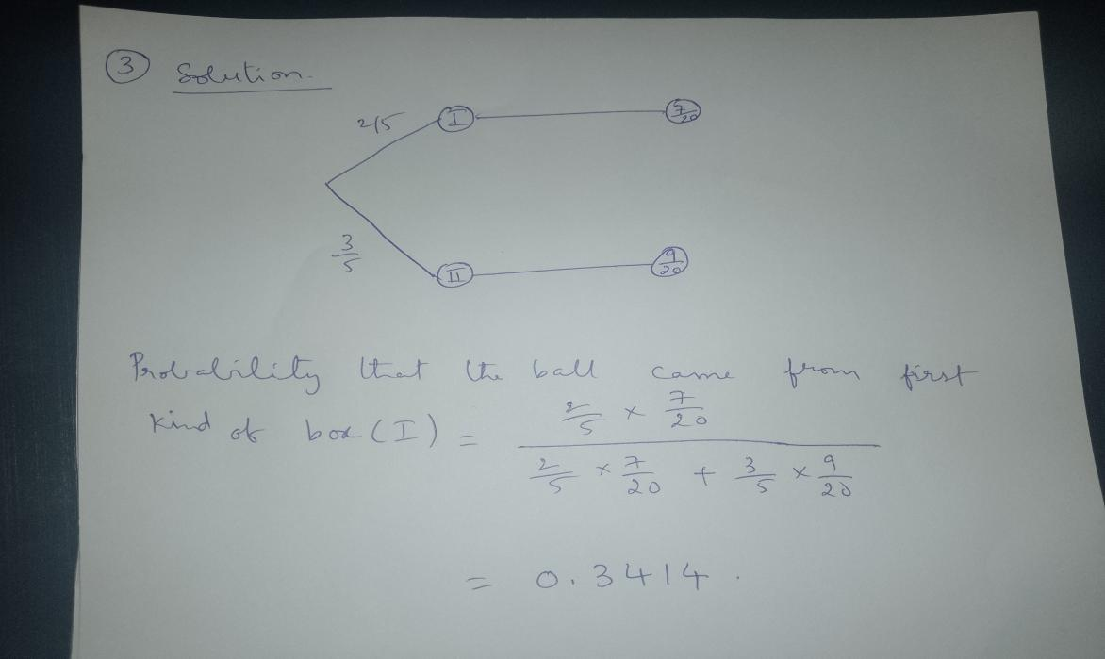

4.A man is known to speak the truth 3 out of 4 times. He throws a die and reports that the number obtained is a four. Find the probability that the number obtained is actually a four.

**Solution:**

Let A be the event that the man reports that number four is obtained.

Let E1 be the event that four is obtained and E2 be its complementary event.

Then, P(E1) = Probability that four occurs = 1/6.

P(E2) = Probability that four does not occur = 1- P(E1) = 1 – (1/6) = 5/6.

Also, P(A|E1)= Probability that man reports four and it is actually a four = 3/4

P(A|E2) = Probability that man reports four and it is not a four = 1/4.

By using Bayes’ theorem, probability that number obtained is actually a four,

          P(E1)P(A| E1)

P(E1|A)    = -------------------------------------------

P(E1)P(A| E1)+ P(E2)P(A| E2)

        1/6 * 3/4

= -------------------------------------     =  3/7

1/6 * 3/4  +  5/6 * 1/4